
投標注意事項:
Bidding Documents Submission Notice:

- 請將所有投標文件備妥並密封於信封內。
Please make sure you have all bidding documents ready, and make sure your tender is in a sealed envelope.
- 請將外標封黏在快遞信封外如圖示。
Please paste our cover sheet on the outside of a forwarder’s envelope as below.
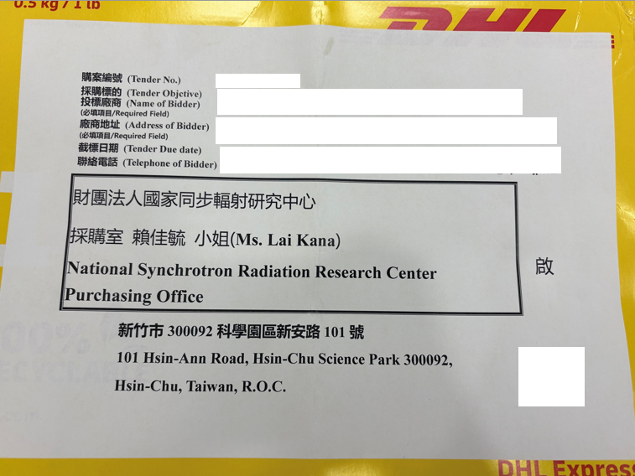
- 本案須檢附以下投標文件:
This required bidding document includes:
■設立登記證明
A Certificate of registration or establishment documents of under applicable law in your country
■用印之標價清單
A signed Submitted Proposal Price List with your Bid Price
■企劃書3份
Proposal in three complete sets, please elaborate on the following items in your proposal:
審 查 項 目 (Examination Item) | 項 目 說 明  (Description) | 配分  (Score)
廠商信譽、履約能力及實績  (Tenderer’s reputation, performance capability and its achievement) | 1.提供曾完成與本案類似之相關鑽石產品經驗，廠商須檢附相關證明文件影本、履約紀錄與實績(Provide the copies of proof document or contract performance for the achievement example of similarly sold diamond product )  2.廠商在全球或在台銷售業績與服務狀況(Provide tenderer’s sale accomplishment statement) | 30 分
技術規格性能  (Tenderer’s technical specifications, performance) | 1.說明可達到本購案要求之規格(State the achievable specifications defined in this procurement)  2.提供鑽石螢光版設計圖面(Provide the top-level assembly drawings required to manufacture the screens in the bid document) | 20 分
履約品質及管理執行能力(Tenderer’s performance quality and its management capability) | 產品交貨時間規劃(State delivery time)  ※請留意交期不得晚於契約規範之交期  ※Please note that a bidder should accept NSRRC required schedule, or offer an earlier delivery schedule. | 20 分
價格(Price) | 價格明細及分析(Provide price list) | 30 分

請於截標前將投標文件送達本中心。
Please submit your documents to NSRRC by closing deadline, 17:00 pm, August 3rd , 2026 (Taipei Time).
※ 請留意投標文件逾期將不予受理。
Please note a late tender will not be considered.

Kind regards,

Kana Lai
Procurement Office
Tel:+886-3-5780281
E-mail address: lai.kana@nsrrc.org.tw

